Need
Heating, Ventilation, and Air Conditioning, or HVAC, systems create a comfortable living space for those who have them installed in their homes. Unfortunately, these systems often heat an entire household when only a small portion of the house is being used. This makes these systems inefficient and costly to run. There is a need to add control to existing HVAC systems so the conditioning efforts of these systems can be focused to areas of the home that are used most frequently.

Objective
The objective of this project is to design and prototype a non-invasive retrofittable system that allows control of existing duct-dampers to allow more precise heating and cooling of the living space. This system will “learn” the schedules of the occupants so rooms can be preconditioned for normal, regular activities as well as accommodate to schedule changes. This allows for a more efficient use of energy than non-occupancy based control schemes.

Marketing Requirements
- Increase efficiency of existing HVAC forced air systems.
- System learns schedules of occupants to increase comfort.
- System is noninvasive to install.
- Visible portions of system are aesthetically pleasing.
- Easily interfaceable with the internet.
- User Interface is intuitive and user-friendly.
- Advanced data input feature to improve efficiency and predictions.
- Simple to install.
- Allows remote, internet control of system.
- User can create preset temperatures for system (i.e. vacation settings, party settings, etc.)

Objective Tree
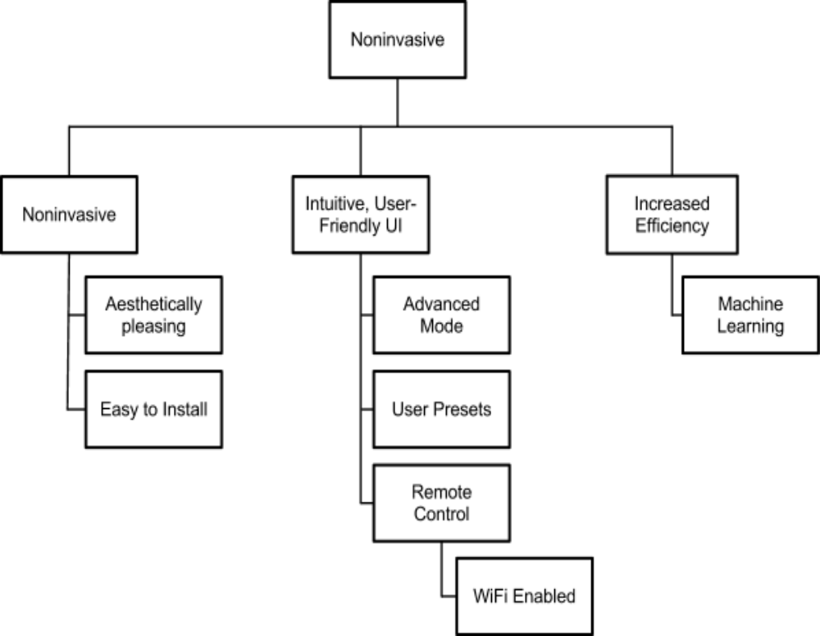

Android enabled programmable camera positioning system

Military utility studies of new infrared imaging technology and processing algorithms often require extensive field testing. These tests generally include the coordination of many sensing systems for day/night operation over long durations in stressing environments. Clearly, automation of these systems is desirable in order to reduce the physical and mental demands on the test team and to ensure measurement repeatability.

For this project, AFRL/RYMT requires an automated infrared camera positioning system. This system will be capable of automatically slewing between target points defined by GPS coordinates at various times according to a preprogrammed test script. To execute this mission, the positioning system must be capable of sensing its own position and orientation in order to calculate the required target acquisition geometry. The positioning system must also be capable of generating an image acquisition command signal to the attached infrared camera (i.e. an electronic trigger to begin and end image collection). Positioning systems such as this exist already but we believe that this work may be done at a significantly reduced price per system by exploiting the sensors and computing power available in commercial Android smart phones.

In considering options to optimize cost versus performance, the student team is free to investigate and propose an alternate solution to this problem.

The students will be responsible for developing hardware for: azimuth and elevation control of a 30 lb sensor; the interface between the hardware and the smart phone; a trigger for the infrared imager; and a software capability for mission scripting. The ability to capture context imagery with the smart phone’s internal camera (or to log other internal smartphone data) would also be beneficial. The hardware solution should be flexible enough so that it may mounted upright for pointing above the horizon or inverted for imaging below the horizon. Elevation pointing range should be 0 to 90 degrees and azimuthal pointing range should be 0 to 360 degrees.

Military utility studies of new infrared imaging technology and processing algorithms often require extensive field testing. These tests generally include the coordination of many sensing systems for day/night operation over long durations in stressing environments. Clearly, automation of these systems is desirable in order to reduce the physical and mental demands on the test team and to ensure measurement repeatability.

For this project, AFRL/RYMT requires an automated infrared camera positioning system. This system will be capable of automatically slewing between target points defined by GPS coordinates at various times according to a preprogrammed test script. To execute this mission, the positioning system must be capable of sensing its own position and orientation in order to calculate the required target acquisition geometry. The positioning system must also be capable of generating an image acquisition command signal to the attached infrared camera (i.e. an electronic trigger to begin and end image collection). Positioning systems such as this exist already but we believe that this work may be done at a significantly reduced price per system by exploiting the sensors and computing power available in commercial Android smart phones.

In considering options to optimize cost versus performance, the student team is free to investigate and propose an alternate solution to this problem.

The students will be responsible for developing hardware for: azimuth and elevation control of a 30 lb sensor; the interface between the hardware and the smart phone; a trigger for the infrared imager; and a software capability for mission scripting. The ability to capture context imagery with the smart phone’s internal camera (or to log other internal smartphone data) would also be beneficial. The hardware solution should be flexible enough so that it may mounted upright for pointing above the horizon or inverted for imaging below the horizon. Elevation pointing range should be 0 to 90 degrees and azimuthal pointing range should be 0 to 360 degrees.

Military utility studies of new infrared imaging technology and processing algorithms often require extensive field testing. These tests generally include the coordination of many sensing systems for day/night operation over long durations in stressing environments. Clearly, automation of these systems is desirable in order to reduce the physical and mental demands on the test team and to ensure measurement repeatability.

For this project, AFRL/RYMT requires an automated infrared camera positioning system. This system will be capable of automatically slewing between target points defined by GPS coordinates at various times according to a preprogrammed test script. To execute this mission, the positioning system must be capable of sensing its own position and orientation in order to calculate the required target acquisition geometry. The positioning system must also be capable of generating an image acquisition command signal to the attached infrared camera (i.e. an electronic trigger to begin and end image collection). Positioning systems such as this exist already but we believe that this work may be done at a significantly reduced price per system by exploiting the sensors and computing power available in commercial Android smart phones.

In considering options to optimize cost versus performance, the student team is free to investigate and propose an alternate solution to this problem.

The students will be responsible for developing hardware for: azimuth and elevation control of a 30 lb sensor; the interface between the hardware and the smart phone; a trigger for the infrared imager; and a software capability for mission scripting. The ability to capture context imagery with the smart phone’s internal camera (or to log other internal smartphone data) would also be beneficial. The hardware solution should be flexible enough so that it may mounted upright for pointing above the horizon or inverted for imaging below the horizon. Elevation pointing range should be 0 to 90 degrees and azimuthal pointing range should be 0 to 360 degrees.

Because this device is part of an Air Force contest, and the device goals are rather specific, implementations of this device are quite similar. They consist of a camera mount, a few servos or motors, a bit of integrated circuitry, and an Android phone. The data processing and control system are all done in software on the phone, and a data connection enables the phone to control the motors to rotate the mount. This exploits most Android's phones hardware, by taking advantage of the GPS, accelerometers, and magnetometers that are present on the phone. A senior design team from Michigan State University also worked on this project in 2012, and their final device came very close to matching the design requirements that were laid out by the Air Force.

The MSU design team almost created the device that the Air Force had laid out. They created a camera mount that could detect its own position, and then point the camera at targets in a pre-defined sequence. The camera mount could travel the required fields for pan and tilt, and they could program a series of movementes. Their Android-motor interface consisted of using the headphone jack as an output, creating control waveforms in software, and sending it to the motor drive subsystem. The motor drive subsystem consisted of a PIC, a few simple logic gates, and amplifiers to drive the actual motors.

While MSU was close to getting what the Air Force wanted, they did fall short in several areas.
One of the major problems the team encountered was the sensitivity and resolution of the Android sensors. The accelerometers and magnetometer would sometimes be off by as much as 10 degrees, well outside of the 2 degree precision outlined in the team's design goal. In addition, the team required a laptop in order to capture images from the infrared camera. This further complicated the Android programming. By using the motion sensors in the phone, the current system does not allow for user interaction when the test is being run. For example, a user cannot interrupt a test sequence if a target goes horribly wrong. They must wait for the test to complete before investigating the problem.

This proposal takes a different route than the MSU team, and even the Air Force design idea. Instead of using an Android phone as the main controller and sensor array, the entire camera control hardware and software would be done via an embedded system, with a battery operated power supply. This has a few advantages over using a phone. It allows for greater positioning sensitivity. The accelerometers in Android phones are intended to detect large changes in orientation, such as when a user goes from portrait to landscape. The accelerometers simply do not have the resolution to perform at the degree level. Also, the design team had problems with the GPS when the device was in doors. Switching to a completely embedded system won't solve this problem, but the battery power supply will. This will allow the device to be portable, and can be set up outside. This will enable a faster, more precise GPS lock. Finally, the design team introduced a laptop in order to communicate with the phone. This added one more device, and one more communication link that could fail.

By taking an embedded approach to this system, the majority of these problems can be eliminated. As stated above, embedded allows for much greater accuracy of the motion sensors. A computer application will allow an operator to control multiple devices over a standard WiFi link. This makes the device more portable. In addition, the operator can abort a test run if something is wrong with the camera. A small, visible light camera can be mounted in the camera mount, and provide the operator with real time images of what the mount is looking at.

Due to the demand from motion picture production, there are plenty of patents that closely relate to this project. For example, Patent US20120313557A1, Camera motion control system with variable autonomy, is a programmable camera positioning mount that's target for professional video production. This patent deals specifically with the camera mounting hardware and the control structure of a semi-autonomous camera positioning system. This system does not have its own, embedded camera, to see where the mount is pointing.

http://www.afrlstudentchallenge.org/

http://www.egr.msu.edu/classes/ece480/capstone/spring12/group03/Documents/FinalReport.pdf

http://www.egr.msu.edu/classes/ece480/capstone/spring12/group03/Documents/480Pre-proposal.pdf

http://www.google.com/patents/US20120313557?dq=android+enabled+programmable+camera+mount&hl=en&sa=X&ei=CbNIUYv8DujA4APApIGADw&ved=0CDQQ6wEwAA

http://www.google.com/patents/US20120249866?dq=pan+tilt+camera+mount&hl=en&sa=X&ei=4bRIUaaWLsfI4AO2_YHACA&sqi=2&pjf=1&ved=0CEMQ6wEwBQ

